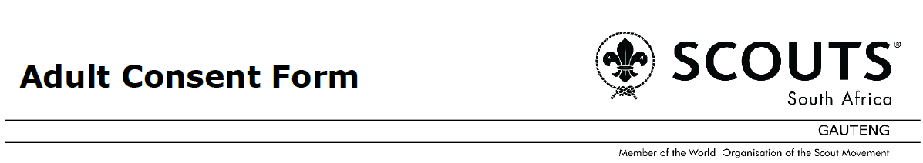
Field Day 2026

Parent / Scouters Details
I, (Full Name) _______________________________ of (Full Residential Address) __________________
____________________________________________________________________________________
hereby make formal application to participate in Field Day 2026 from the 14th to 16th August 2026 held at Ditsong Willem Prinsloo Agricultural Museum, Gauteng and the activities associated and connected with it.
I hereby appoint and authorise the Scouter in charge to act in my place, and if necessary to consent to my undergoing surgical or other medical treatment. I undertake to pay the cost of such treatment where required.
I fully understand and accept that all activities are undertaken at my own risk.
I am aware that neither the South African Scout Association, nor its Scouters, accept responsibility for any loss, injury or damage that I may sustain whilst engaged in any Field Day activity. I waive any right that I may have to claim compensation against the South African Scout Association or any of its Scouters or other members in respect of any loss, injury or damage incurred whilst engaged in any Field Day activity howsoever arising and I indemnify them against all claims.
(*) Please delete that which does not apply:
I certify to the best of my knowledge, that I (full name): ______________________________________________________________________
1. Am / am not (*) suffering from a physical disability or illness which makes it inadvisable for me to attend Field Day 2026 (If “am”, please provide details):
______________________________________________________________________
2. Am / am not (*) suffering from any infectious disease and have / have NOT (*) been in contact with anyone so suffering during the past 14 days. (If “am” and/or “have”, please provide details):
______________________________________________________________________
3. Am / am not (*) on any medication. (If “am”, please provide details):
______________________________________________________________________
4. Do / Do not (*) suffer from an allergy / disability / health problem (If “do”, please provide details):
____________________________________________________________________________________
SIGNED: _____________________________ WITNESS 1: ____________________________
DATED: this ______ day of _______________2026 WITNESS 2:_____________________________
At (place) ________________________________
In case of an emergency during Field Day 2026 my contact number and other details are:
Tel (Home): ______________________________ Relative’s Cell Phone: _____________________
Tel (Work): _______________________________ Name of Family Doctor: ___________________
Cell Phone: _______________________________ Doctor’s Phone: __________________________

