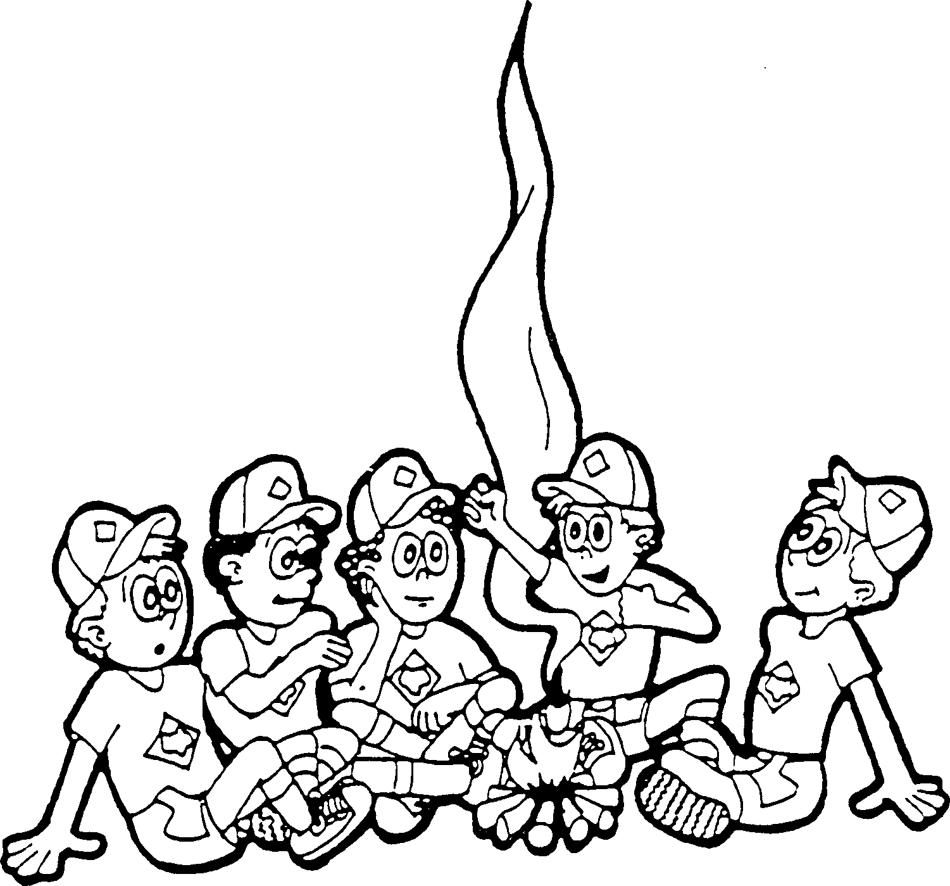
Dear Parents
Ubuntu Camp 10-12 February 2023

Please take of the following details pertaining to the upcoming camp. The aim of camp is to learn from scouts from difference troops and have fun in the true sprint of Ubuntu.

Dates and Time: From [Insert Time] on the 10 February until [Insert Time] on the 12 February 2023.

Where: Arrowe Park (Ebenezer St, Lakefield, Benoni)
Cost: [Insert Cost] (To be handed in by the [Insert Payment Method and Due Date for Monies])
Transport: All scouts to meet at the [Scout Hall/Arrowe Park] by [Insert Time] on the 11th February. Scouts can be collected from the [Arrowe Park] at [Insert Time] on the 13th February 2022.
Consent Form: To be completed and handed in on [Insert Due Date].
Confirmation Closing Date: [Insert Due Date].

Kit List:
- Mess kit (Plate, bowl, mug, knife, fork, spoon, dish towel)
- Raincoat or windbreaker
- Comfortable Walking Shoes
- Small Water Bottle
- Warm Blankets/Sleeping Bag, blue foam camping mattress and pillow
- Toiletries (Toothbrush, toothpaste, hairbrush, soap, towel, shampoo, etc.)
- Torch
- Clothes for 2 Days (Warm Jacket, 3 Shirts, 2 Shorts, 1 Pair Longs and 1 Beanie)
- Sunblock, hat, costume and towel
- Water Shoes/Closed Shoes that can be worn in the dam
- Uniform (To be worn to and from Camp)
- Optional: Campfire blankets and camping chair

If you have any queries, please feel free to contact me on the details below.
Yours in Scouting
[Contact Person]
[Patrol Name]
Cell: [Cell Number]
Email: [EmailAddress]

